1.Execution of a while loop printing numbers in a given range.

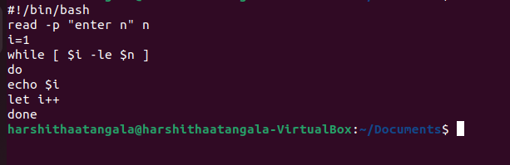

2.Write a shell script to print whether the string enetered by the user is empty or not

